# Bilinear interpolation

## Abstract

The unit calculates the mean average of 4 given gray-scale values.

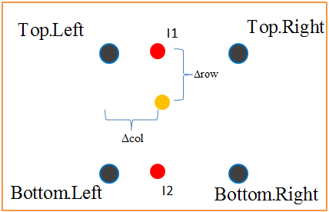



## Inputs

|  |  |  |  |  |
| --- | --- | --- | --- | --- |
| **Name** | **description** | **type** | **size** | **Recived from** |
| Pix_1_in | Value of 1st requested pixel | Std_logic_vector | 16/**8**? | Local_register/SDRAM? |
| Pix_1_in | Value of 2nd requested pixel | Std_logic_vector | 16/**8**? | Local_register/SDRAM? |
| Pix_1_in | Value of 3rd requested pixel | Std_logic_vector | 16/**8**? | Local_register/SDRAM? |
| Pix_1_in | Value of 4th requested pixel | Std_logic_vector | 16/**8**? | Local_register/SDRAM? |
| delta_row_out | Holds the delta of row, for bilinear-interpolation | Std_logic_vector | 7 (trig_frac_size_g-1 downto 0) | Addr_calc |
| delta_col_out | Holds the delta of col, for bilinear-interpolation | Std_logic_vector | 7 (trig_frac_size_g-1 downto 0) | Addr_calc |

## Outputs

|  |  |  |  |  |
| --- | --- | --- | --- | --- |
| **Name** | **description** | **type** | **size** | **Destination** |
| Pixel_res | Gray scale value for output image | Std_logic_vector | 16/**8**? | WB to Sdram |
| Pixel_valid | Valid signal for result | Std_logic | 1 | manager |
|  |  |  |  |  |

## Simulation

**Matlab Output for comparison**

**ModelSim Output**

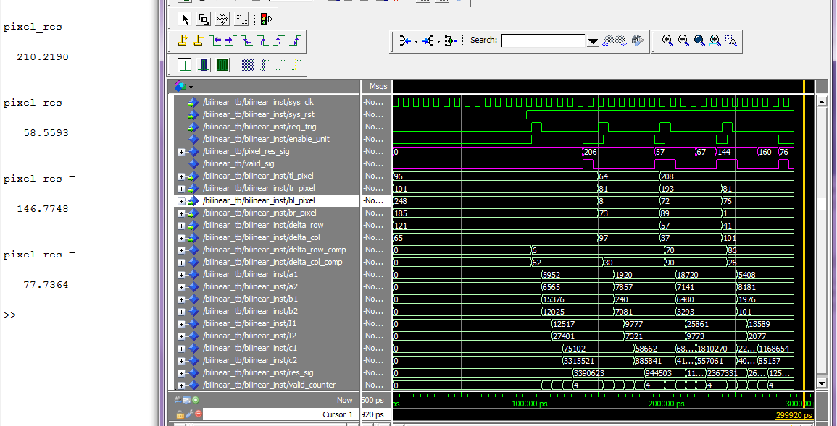

Trigger + Input

Result + Valid

* we can see an error margin of 4 grey scale levels which means 1% in 8 bit image (256 grey levels)
* 5 cycles after trigger result is ready